7th lecture

6.4 Measuring E and D in an insulator

How can we measure E and D in an insulator? Obviously we cannot penetrate into the insulating medium to perform a measurement there, between the molecules of the insulator, because we would need measuring instruments of atomic or subatomic sizes. Even if we would have such fantasy instruments, our continuous medium model would be useless, as the instrument would be too close to the dipole molecules.
The solution of the above problem is to prepare a cavity within the insulator with such a shape which can guarantee that the E or the D field within the cavities is
identical to the field inside the insulator. If we can carve such macroscopic cavities into the insulator then we can put our instruments there to measure E and D. As we will see in the case of measuring E the cavity should be a narrow cylinder with an axis which is parallel to the elctric field at that point. In the case of measuring D the cavity should be a flat cylinder where both its top and bottom is perpendicular to D. For the shake of simplicity in the following we will assume homogeneous and isotropic dielectric media. In the case of polarization we will assume that E and P, consequently also E and D are parallel. (For anisotopic materials, like crystals for example, that condition does not necessarily holds, but we are not going to discuss the behavior of such materials here.)

Measurement of E in an insulator
For an instrument measuring E a cylindical cavity should be „drilled” into the insulator with an axis of symmetry, which is parallel with E. As P is parallel with E (isotropy), P will be also parallel with the cylindrical surface, consequently the polarisation charge density shoud be zero there. This is because the normal vector n of the cylindrical surface is perpendicular to P everywhere as
$s_{\text{pol}\text{.}}=P⋅n=0$.
Thus no polarization charges appears on the cylindrical surface. Then the normal component of E should be the same (i.e. zero) at both sides of the cylindrical surface in the insulator and also inside the cavity (which contains vacuum or air):
E_{n}(in the insulator) = E_{n}(in the cavity) = 0
This is because according to the first law of electrostatics for surface charge distributions:
D_{n}(in the cavity) – D_{n}(in the insulator) = σ_{pol} = 0,
thus
ε₀E_{n}(in the cav.) + P_{n}(in the cav.) – [ε₀E_{n}(in the ins.) + P_{n}(in the ins.)] = 0.
We know, however, that P(in the cavity) = 0 and P_{n}(in the insulator) is also zero, consequently E_{n}(in the insulator) = E_{n}(in the cavity).
According to the first law of electrostatics the tangential component of the electric field strength should be the same on both sides of a surface:
E_{t}(in the cavty) = E_{t}(in the insulator).
As both the normal and the tangetial component of the electric field strength is the same on the both sides of the surface separating the insultor medium from the space of the cavity we can conclude that
E(in the insulator) = E (in the cavity).
Consequently we can measure the electric field strength inside the cavity with the usual the test charge method and the result obtained this way will be valid also for the insulator.
When carving the cylindrical cave it is important that the base and the top of the cylinder be as small as possible. This is because polarization charges appear on these surfaces, which modify the electric field. The effect of polarization charges appearing on the base and the top of a narrow cylinder can be neglected, however, in the middle of a narrow cavity.

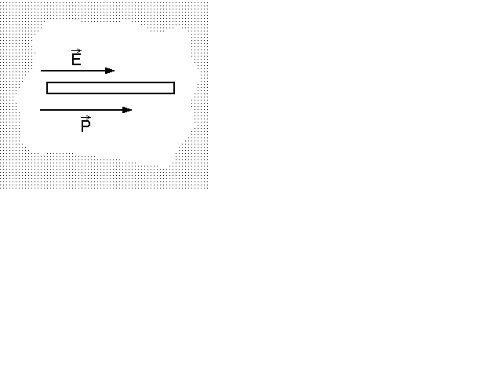 | 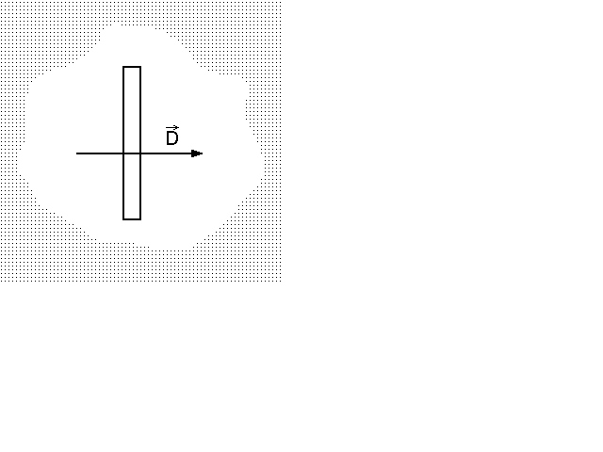
a) Cavity for the measurement of E | b) Cavity for the measurement of D

Measurement of D in an insulator
For the measurement of D we have to dig a flat cavity, a flat cylinder, the base and the top of which is perpendicular to the D field there. According to the first law of electrostatics for the top or the bottom of the flat cylinder
D_{n}(in the cavity) - D_{n}(in the insulator) = σ_{free} = 0,
because there are no free charges only polarization ones on these surfaces. Consequently
D_{n}(in the cavity) = D_{n}(in the insulator).
We want to prove that D(in the cavity) is equal to D(in the insulator). This is true if both the normal and the tangential components are the same. We know that D is perpendicular to the newly cut surface inside the insulator. We have to prove, however, that it has the same direction inside the cavity, that is it has no tangential component. To prove that we will apply the second law of electrostatics. Inside the insulator the E field has no tangential component as it should be parallel with D in an isotropic medium. Now, according to the second law of electrostatics
E_{t}(in the cavity) = E_{t}(in the insulator) = 0,
consequently
D_{t}(in the cavity) = 0.
This is because inside the cavity D= ε₀E as P = 0 there.
The cavity should be as flat as possible because the electric field is inhomogeneous close to the edges of the cavity (like in the case of a parallel plate capacitor) but these inhomogenities can be neglected in the middle of a flat cavity.
To measure the D field inside the cavity we can use our traditional „fry pan” method.

6.5 On the material equation P=P(E) . The electric susceptibility. Absolute and relative permittivity

Insulators can be polarized with various means thus P the polarization of a material may depend on several things. P may depend even on the history of the material. For example if polymer melt, while cooling down, solidifies in an electric field then the orientation of the dipoles, consequently its polarization P will be frozen. This way the solid polymer „remembers” the polarizing field. Mechanical stress can also polarize certain crystals. This is the so called piezoelectricity which will be discussed later. In most cases, however, polarization is due to an electric field. In this case (in the absence of other factors) P depends on E exclusively
P = P(E).
The above equation is the material equation of polarization, which is the first among the 3 material equations associated with the 4 Maxwell equations.
LIH dielectrics
Very often (but not always!) the P-E relationship is linear
P ∝ E or P = k⋅ E.
Two other common assumption are that the dielectric material is isotropic and homogeneous. LIH dielectrics is a linear, isotropic an homogeneous dielectric medium. The linear relationship between P and E is usually written in the following form
$$P={\text{χε}}_{0}E ,$$
where k, the factor of proportionality k = ε₀χ .χ (or χ_{e} ) is the so called electric susceptibility. For a LIH dielectrics the D-E relationship is also linear and can be written as:
$$D=ε_{0} E+P=ε_{0} E+ε_{0} γE=ε_{0}(1+χ)E=ε_{0}ε_{r} E=ε E ,$$
where $e_{r}=(1+c)$ is the so called relative permittivity, while $ε=ε_{0}ε_{r}$ is the absolute one. Thus in the case of a LIH dielectrics the following simple linear relationship holds between D and E :
$$D=ε E \text{.}$$
We have to emphasize again that the above formula is valid for LIH dielectrics only, and not all dielectrics are LIH ones.

6.6 Various mechanisms of polarization
Orientation and induced polarization:
This was already discussed. Now we will focus on more „exotic” mechanisms of polarization.

Piezoelectricity
Polarization of an insulator occurs when the positive and negative charges are separated within the insulator forming oriented dipole chains. This can occur under the influence of a polarizing electric field but a mechanical stress can also create dipole chains in certain materials. This effect is called piezoelectricity, which was discovered by the Curie brothers (Pierre and Jacques) in 1880.
The Curie brothers observed that on the surface of certain crystals (e.g. quartz or turmaline) polarization charges appear when the crystals are deformed. In 1881 Lippmann predicted the reciprocal effec the electrostriction, when the crystal is deformed under the influence of an applied voltage. Following Lippmann’s ideas the Curie brothers could observe elctrostriction experimentally. The piezoelectic effect and its reciprocal the electrostriction is applied in several fields of the everyday life like gas lighters, the quartz watches, piezoelectric microphone and laudspeaker, etc. More can be read about piezoelctricity on the internet especially on the http://www.piezo.com web page.

Ferroelectricity

As it was mentioned earlier not all insulators are LIH dielectrics. Asan example let us see the polarization P-E diagram of a ferroelectric material! (Examples for ferrielectric materials: KNaC₄H₄O₆.4H₂O (potassium-sodium tartarate) and BaTiO₃ (barium titanate)

Hysteresis loop

Explanation

Thermal effect: the Curie point

Application of ferroelectric materials (reading).

Electrets
electret = electr(ic) + (magn)et

Application of electret foils

Inventors: Gerhard Sessler and James West at the Bell Labs in 1962
.
The concept of the capacitor microphone

The concept of the electrete microphone.

Other applications: electrete foils to remove dust particles. Transparent foil sticks to the window.

7. Magnetostatics

7.1 The fundamental experiment of magnetostatics

The fundamental experiment of magnetostatics is performed with a permanent magnet and a piece of iron e.g an iron key. (Or with any so called soft ferromagnetic material, that is with a material, which cannot be magnetized permanently.) The permanent magnet attracts the key, which sticks to it and stays there as long as we leave it there.
Comparison with the fundamental experiment in electrostatics
For comparison we briefly recall similar experiments in electrostatics performed with a charged glass rod and a small piece of
- a conductor e.g. an aluminum foil or
- an insulator e.g. cotton.
i) The electric field of the glass rod induces a separation of the free charges in the conducting foil. The positive charge of the glass rod and the induced negative charge on the foil attract each other and the attracting force pushed the foil toward the rod. As soon as the foil touched the glass rod, however, some of its electrons flowed into the glass rod, both bodies got positively charged and the aluminum foil was pushed away immediately.
ii) In the case of the insulating cotton the events were somewhat different. The rubbed glass rod first attracted the cotton piece, which sticked to the rod and was not pushed away immediately like the aluminum foil. Waiting some seconds, however, the glass rod suddenly pushed away the cotton piece as well, indicating that after this time the two bodies became charged by like charges.
We explained the attraction by the polarization of cotton. The field of the glass rod induced polarization charges on the surface of the cotton. Due to that polarization the glass rod and the nearby surface of the cotton became oppositely charged and these oppositely charged surfaces attracted each other. We also emphasized that if the cotton and the glass rod were ideal insulators then this state of attraction would last an infinitely long time, and the cotton would stick to the glass rod forever. This was not the case, however. A part of the positive free charge on the glass rod migrated gradually to the cotton and finally the repulsive force between the positive free charge on the glass rod and on the cotton became larger than the attractive forces due to the polarization charges. At this point the cotton was repelled. This proves that the cotton is not a perfect insulator: it does not block the motion of some free charges completely.
Charging of the cotton required some time, however, because cotton is a very poor conductor. The mechanism of the conduction in a poor conductor is not quite clear presently. The charge carriers can be electrons, holes or maybe ions. The important thing, however, is not the mechanism of the conduction, but the fact, that free charges are able to move in cotton. Other insulating materials, like poly(tetrafluoroethylene), ceramics or quartz are much better insulators but none of them is perfect.
Interpretation of the fundamental experiment in magnetostatics
Now let us go back to the fundamental experiment of magnetostatics. The permanent magnet is a magnetic dipole. One pole, attracted by the North magnetic pole of Earth, is called as the North pole of the magnet (denoted by N), while the other one is the South pole (denoted by S). It is important to mention that the poles of the permanent magnet are polarization poles: we cannot separate them to two free magnetic poles. (Free magnetic poles are the so called magnetic „monopoles”.) For example if we break the permanent magnet into two smaller pieces (we perform this experiment during the class) then we obtain two smaller dipoles but not two monopoles.
Either the North or the South pole of the permanent magnet can polarize a piece of iron. Then attractive forces appear between the opposite polarization charges and the small iron piece sticks to one of the poles and stays there forever if we do not separate them. This is a very important difference compared to electrostatics. All other ferromagnetic materials behave similarly indicating that there is no free magnetic pole in these materials which could move freely independent of the opposite pole. No „magnetic current” carried by magnetic monopoles was observed until now.

7.2 Search for the magnetic monopole
Do magnetic monopoles really exist? Presently we do not know the answer. Some theories predict the existence of subatomic particles which are magnetic monopoles and we are not aware of any law of the Nature which would exlude their existence. Thus they might exist. In the second half of the 20th century there were several experimental programs aiming to find such particles but they ended without any success. Anyway, we can conclude that even if magnetic monopoles exist they should be very rare and difficult to find.

7.3 The electric polarization charge and the magnetic polarization pole
As we have already mentioned permanent magnets are magnetic dipoles. There are two poles in a magnet: a North pole and a South pole. These poles are not monopoles, however, they are polarization poles only. This means that these poles cannot be separated by cutting the permanent magnet into smaller pieces.
The situation is analogous to an electret where the electric field of the electret is established by polarization charges. These polarization charges cannot be separated by cutting the electret into smaller pieces as long as we are not allowed to cut either the molecules (such a cut is equivalent to a chemical reaction) or the atomic nuclei (a fission of the nucleus would be a nuclear reaction).
Thus the analogy between the polarization poles and the polarization charges ends when any means are allowed to separate the opposite poles and the opposite charges. If chemical reaction is allowed we can make free charges from polarization charges (e.g. by removing electrons from some molecules) but, according to our present knowledge, we are not able to separate free monopoles from a permanent magnet or from a polarized magnetic material, even if any means are allowed to do that.
This difference does not mean, however, that polarization poles are not „real” poles. They are true poles in every respect except they cannot be isolated as monopoles because they are polarization poles and not free ones.
és ha ennek a belső szerkezetével nem törődünk, akkor ezt nyugodtan reprezentálhatjuk két mágneses pólussal.

7.4 Fundamental equations of magnetostatics from Maxwell’s equations

$\text{rot} H=0\text{.}$ Maxwell’s first eqation in the case of statics ( j= 0 , ∂D/∂t = 0, and ∂B/∂t = 0)
thus the magnetostatic field is free of vortices. Moreover, according to Maxwell’s third equation there is no free magnetic pole (or monopole)
$\text{div} B=0\text{.}$thus B, the field of magnetic induction has no source: its source density is zero.

7.5 The magnetic Coulomb’s law

As we know permanent magnets are magnetic dipoles with two polarization poles. If these dipoles are long enough then we can study the interaction of the poles of two different dipoles. (Naturally to the interaction of two different dipoles all the four poles contribute but the contribution of the poles which are close to each other can dominate.) According to the experiments when a pole of a magnetic dipole with a pole strenth p is placed into the origin of a coordinate system then the force acting on the test pole p_{T} whose radius vector is r
$F_{p}=\frac{1}{4{\text{πμ}}_{0}}\frac{p p_{P}e_{r}}{r^{2}},$where μ₀ = 4π×10⁻⁷ V⋅s/(A⋅m) is the permeability of the vacuum. μ₀ is playing a role in the above magnetic Coulomb’s law which is analogous to the role of ε₀ in the original (electric) Coulomb’s law. As we remember the unit of the electric charge is the Coulomb = A⋅s. The analogous unit of the magnetic pole is the Weber = V⋅s. Two magnetic poles would repell (like poles) or attract (opposite poles) each other from a distance of one meter with a foce
F = 10⁷/(4π)² = 6.33×10⁴ N
We can also introduce the magnetic field strength H, in an analogous way to the electric feield strength E:
$H=\frac{F_{p}}{p_{p}}\text{.}$
where F_{T} is the force acting on the test pole p_{T}. The unit of the magnetic field strength is N/Weber = (V⋅A⋅s/m)/( V⋅s) = A/m. (Observe that the units of the analogous magnetic quantities can be obtained if we change A to V and V to A in the analogous electric unit. )
In spite of these analogies the measurement of the magnetic field strength is performed in a different way. This is because in SI the measurement of all electric and magnetic quantities should be traced back to an electric current measurement as the basic electric unit in the SI is the Ampere. Thus an unknown magnetic field strength is measured by comensating it with a magnetic field of a current. (The details of that method will be discussed later.)

7.6 The magnetic field in materials. The M=M (H) material equation

Here we give the analogous electric and magnetic quantities in the form of a „dictionary”.

E (electric field strength) ⇔ H (magnetic field strength)

D (electric induction) ⇔ B (magnetic induction)

P (electric polarization) ⇔ M (magnetic polarization)

ε₀ (permittivity of the vacuum) ⇔ μ₀ (permeability of the vacuum)

D = ε₀⋅E + P ⇔ B = μ₀⋅H + M

anyagi egyenlet: P = P(E) ⇔ anyagi egyenlet: M = M(H)

ferroelectricity , ferromagnetism,
hysteresis . Polarized domains ⇔ hysteresis . Magnetic domains
Curie point Curie point

The material equations are often linear both for electric and magnetic materials. In the case of linearity the following equations are valid:

P = ε₀χ_{e}E ⇔ M = μ₀χ_{m}H

D = ε₀E + ε₀χ_{e}E ⇔ B = μ₀H + μ₀χ_{m}H

D = ε₀ (1 + χ_{e}) E ⇔ B = μ₀ (1 + χ_{m})H

χ_{e} = electric susceptibility ⇔ χ_{m} = magnetic susceptibility

(1 + χ_{e}) ≡ ε_{r} ⇔ (1 + χ_{m}) ≡ μ_{r}

ε_{r} = relative permittivity ⇔ μ_{r} = relative permeability

ε = ε₀ε_{r} ⇔ μ = μ₀μ_{r}

ε = absolute permittivity ⇔ μ = absolute permeability

D = εE ⇔ B = μH

Dielectric materials ⇔ paramagnetic materials

(χ_{e}>0, ε_{r}>1 ) (χ_{m}>0, μ_{r}>1)

no analogy × diamagnetic materials
(χ_{m}<0, μ_{r}<1)

In a few words:
Explanation of paramagnetism. Spin, magnetic moment. ESR.
NMR: chemical shift.
Explanation of diamagnetism.

